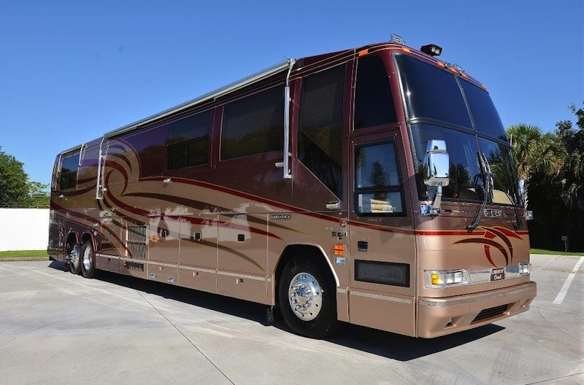

2000 Prevost Liberty Elegant Lady H3  
$209,000.00

122,900 Miles - Beautiful Interior - Like New - Garage Kept - Luxurious Stone Floors

Recently Replaced Tires - New House Batteries - New Chassis Batteries

New in Motion Satellite - Headlight Upgrades- New 42" Salon TV - New LED HD Bedroom TV

Updated Audio Video System with Blue Ray front and rear Headlight Upgrade for better Night Vision and esthetics Paint and body is in excellent shape - Series 60 Detroit Diesel Engine - Allison 6 speed Automatic Transmission

4- 14,000 BTU Cruise Air Reverse Cycle heat pump air conditioning systems with SMX controls

Air conditioning ducted through ceiling with concealed return air grills

80,000 BTU Webasto with soldered hard wall copper plumbing with 6 heat exchangers continuously circulating hot water heat through the main engine and domestic water heater.

20 K W Kohler generator on roll-out with centrally controlled air bag suspension

1 maintenance free generator starting battery with auto boost from house batteries

Exclusive Liberty Coach engineered Battery Watchdog automatic generator starting system

Shore power inlets on both port and starboard sides Remote TV speakers centered over each couch

JVC Stereo VCR located in front overhead

Bose Lifestyle 30 Dolby Pro-Logic surround sound system with AM/FM and 6 disc CD changer in living room and bedroom

CB radio with remote external speaker

Alpine navigation system that includes a 5” color screen, which displays the AM/FM radio functions as well as the back-up camera.

180 gallon stainless steel fresh water tank

180 gallon holding tank

20 gallon electric water heater and winterizing bypass Beautiful Ceramic tile shower with 1/2 round glass shower door

Corian double-bowl galley sink with sink cover - 20 SQ foot Amana built-in style refrigerator with ice and water dispenser

Washer and Dryer - Custom sofas - Air bed deck lift - Storage area under bed - Large safe under bed

Electric privacy shades for driver and passenger with controls at driver’s dash and passenger cabinet for upper and lower windows

Electric sun shades for driver and passenger with controls at drivers dash and passenger cabinet Exclusive Liberty Coach custom upholstered driver’s dash with illuminated dash - Isringhausen air-ride custom upholstered leather driver’s seat with electric base

Exclusive time-proven Liberty Coach designed Auto Level system with independent front, left rear and right rear manual override

Hot and cold water faucet in water tank compartment with hand sprayer

Priced to sell. Please contact **Doug Stolfo** at **(407) 302-9139** or [**doug.excalibur@gmail.com**](mailto:doug.excalibur@gmail.com)